Topic | C2 Topic 1 Atomic Structure & The Periodic Table | C2 Topic 2 Ionic Compounds & Analysis | C2 Topic 3 Covalent Compounds & Separation Techniques | C2 Topic 4 Groups in the Periodic table | C2 Topic 5 Chemical Reactions | C2 Topic 6 Chemical Calculations
Presentations to support learning | See your class OneNote
Web links | Topic Revision   | Topic Revision   | Topic Revision   | Topic Revision   | Topic Revision   | Topic Revision  
YouTube | The Periodic Table    Atomic Structure   | Ionic Bonding   | Covalent Bonding    Separation Techniques   | Alkali Metals    Halogens   | Rates of Reaction | Calculations  
Practice questions | See your class OneNote
Teacher tips | Don’t forget Mendeleev and his predictions and pair reversals.  Draw your electron configurations neatly! | Practice naming formulae    Learn the polyatomic ions.. | Make sure you know your key words; soluble, insoluble, solvent, distillate, filtrate, precipitate. | ALWAYS make use of the periodic table you get with each exam. | Know the four ways a rate of reaction can be increased- surface area, temperature, concentration & catalysts. | Know how to calculate Mr, Theoretical Yield, Percentage Yield and Empirical formula.



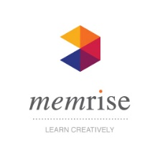

Specifications for additional Science.…
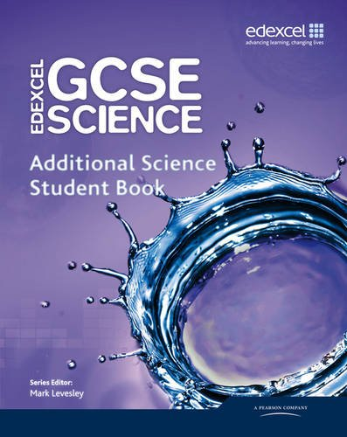
Ready-made flash cards to quiz yourself!
Y11 CHEMISTRY REVISION LINKS

